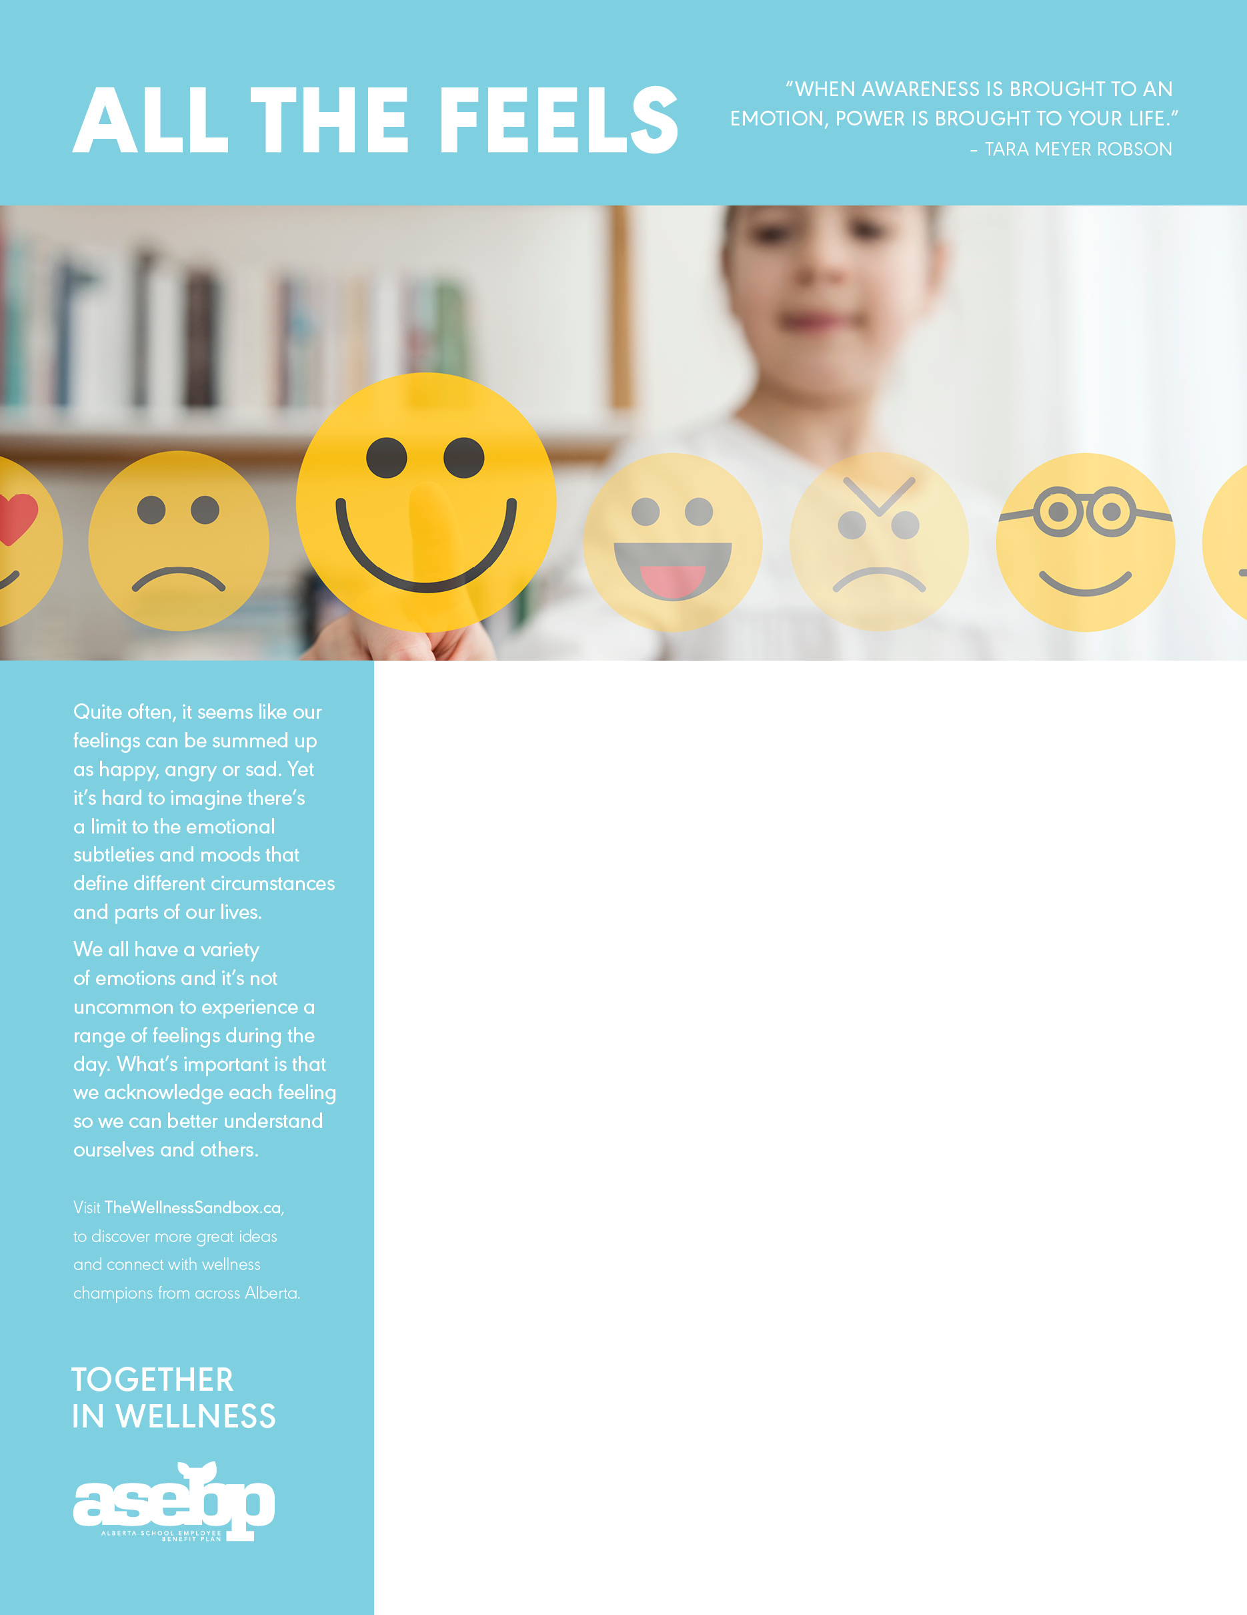

**ADD YOUR WORKPLACE WELLNESS TITLE HERE**

Add your workplace wellness information here! Here are a few ideas that you might include:

* Information about upcoming wellness initiatives or challenges in your workplace;
* Highlight services related to the theme, like your EFAP or ASEBP benefits;
* Share inspirational wellness quotes;
* Feature dates for wellness events happening in your community; or
* Browse through [The Wellness Sandbox](https://www.thewellnesssandbox.ca/) for even more ideas!

RELATED RESOURCES:

Course: Free courses on Homeweb help you dig a little deeper into your emotions. Check out [Taking Control of Your Mood](https://homeweb.ca/courses/564a3b6fad33f8e259390025) for some self-care strategies for improving sad moods.

Info Graphic: Use one of these free [Emotion Info Graphics](https://www.rewardcharts4kids.com/feelings-chart/) in a common area to start the conversation.

Research: [Reading Facial Expressions of Emotion](https://www.apa.org/science/about/psa/2011/05/facial-expressions), published by the American Psychological Association, explores the universality of facial expressions of emotion and the existence of microexpressions.

Support: The Canadian Mental Health Association’s [Not Myself Today](https://www.notmyselftoday.ca/) program is a great way to recognize our wide range of emotions, while at the same time acknowledging we all have ‘off days.’

Video: Watch Liz Fosslien’s 5-minute TED Talk, [The Way We Work](https://www.ted.com/talks/liz_fosslien_how_to_embrace_emotions_at_work#t-2048), on why selective vulnerability is key to bringing your authentic self to work and finding the balance between sharing too much and not enough.