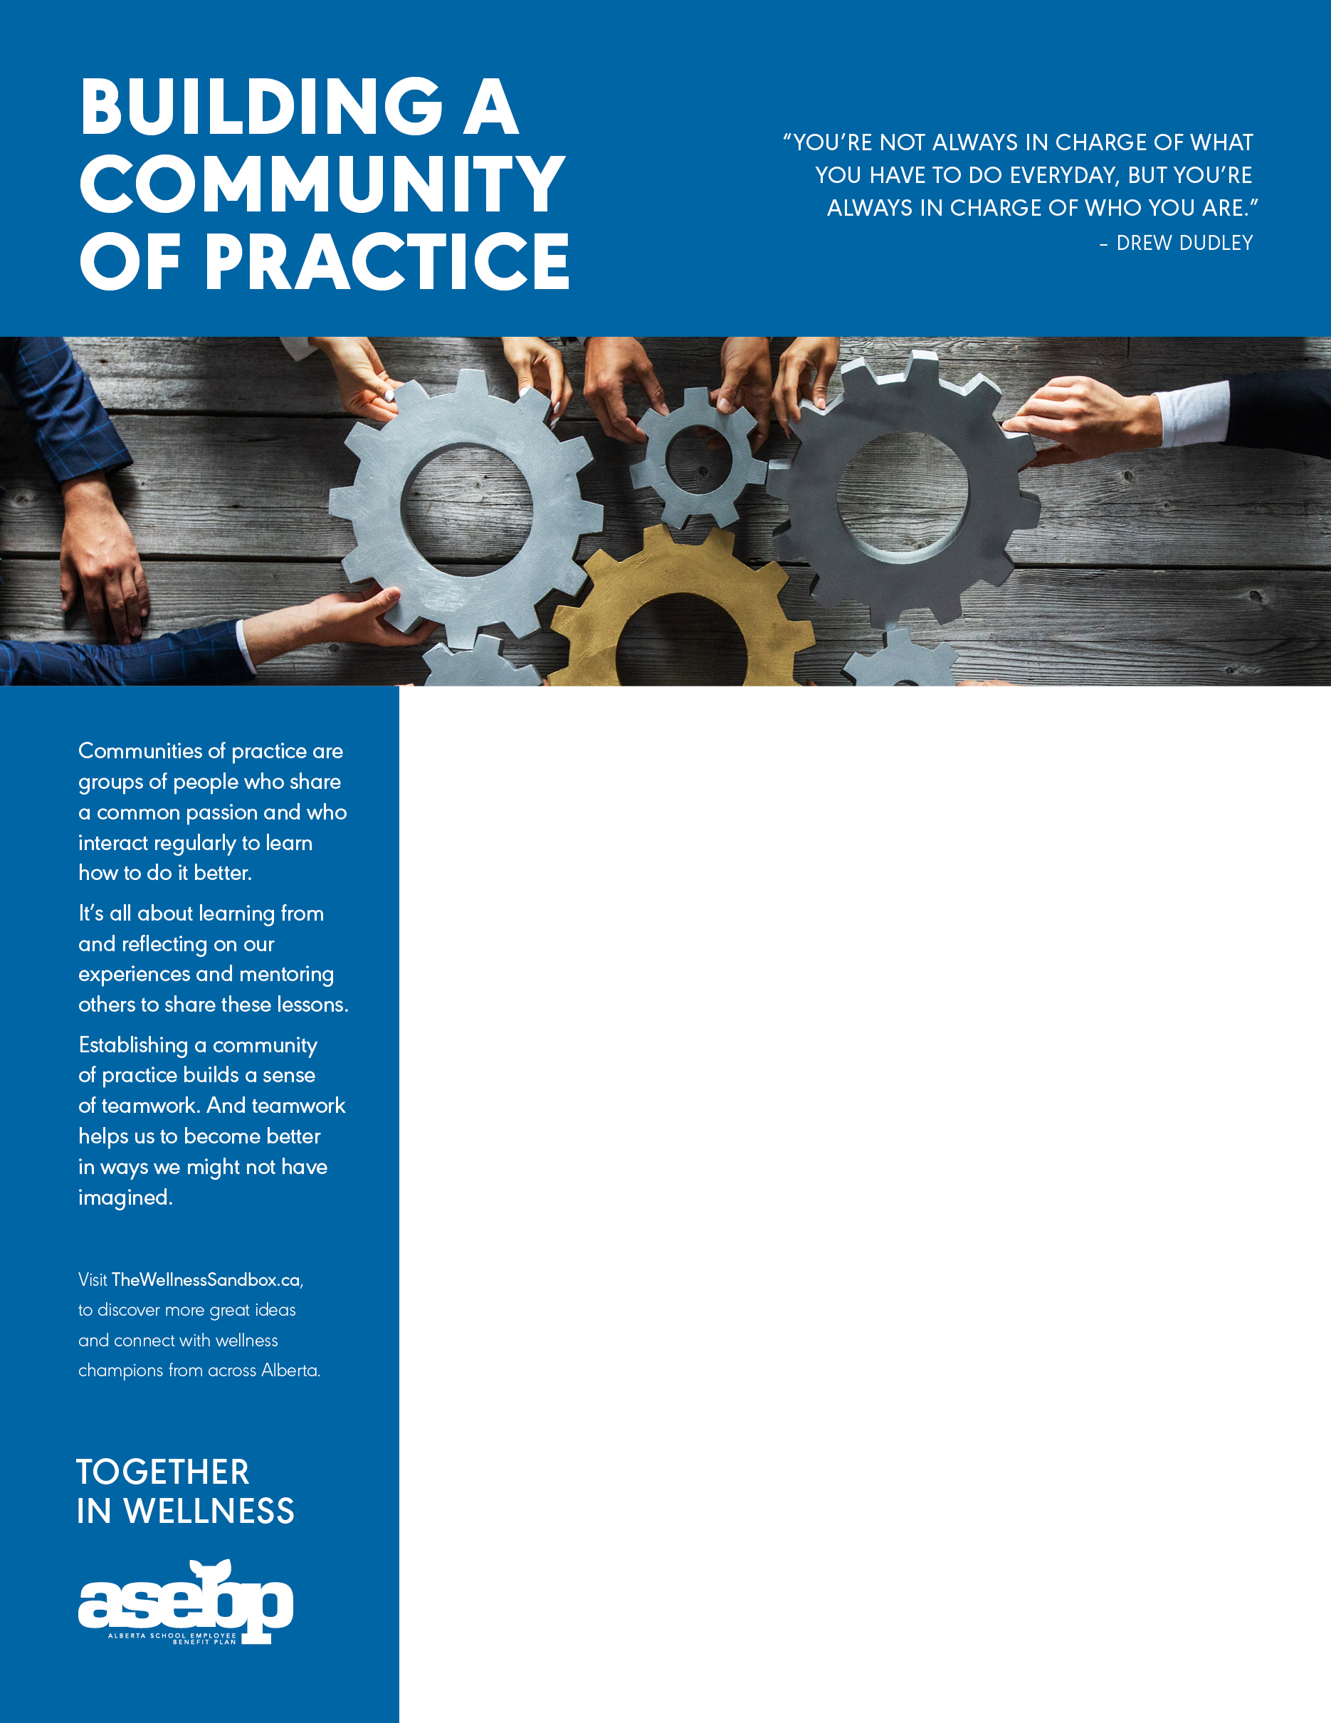

**ADD YOUR WORKPLACE WELLNESS TITLE HERE**

Add your workplace wellness information here! Here are a few ideas that you might include:

* Information about upcoming wellness initiatives or challenges in your workplace;
* Highlight services related to the theme, like your EFAP or ASEBP benefits;
* Share inspirational wellness quotes;
* Feature dates for wellness events happening in your community; or
* Browse through [The Wellness Sandbox](https://www.thewellnesssandbox.ca/) for even more ideas!

RELATED RESOURCES

Activity: The EdCan Network provides a number of easy activities for [leading memorable and productive discussions](https://www.edcan.ca/wp-content/uploads/cea-2014-discussion-guide-v2-0.pdf) within education settings.

Course: Developed by Ever Active Schools and a number of other education partners, the [Building Healthy School communities course](https://cshhub.com/course/) is a free e-course that lays a foundation for understanding well-being in education contexts.

Website: This [website](http://www.communityofpractice.ca/), created by Alberta educational leaders, provides many activities and much information on building education communities of practice.