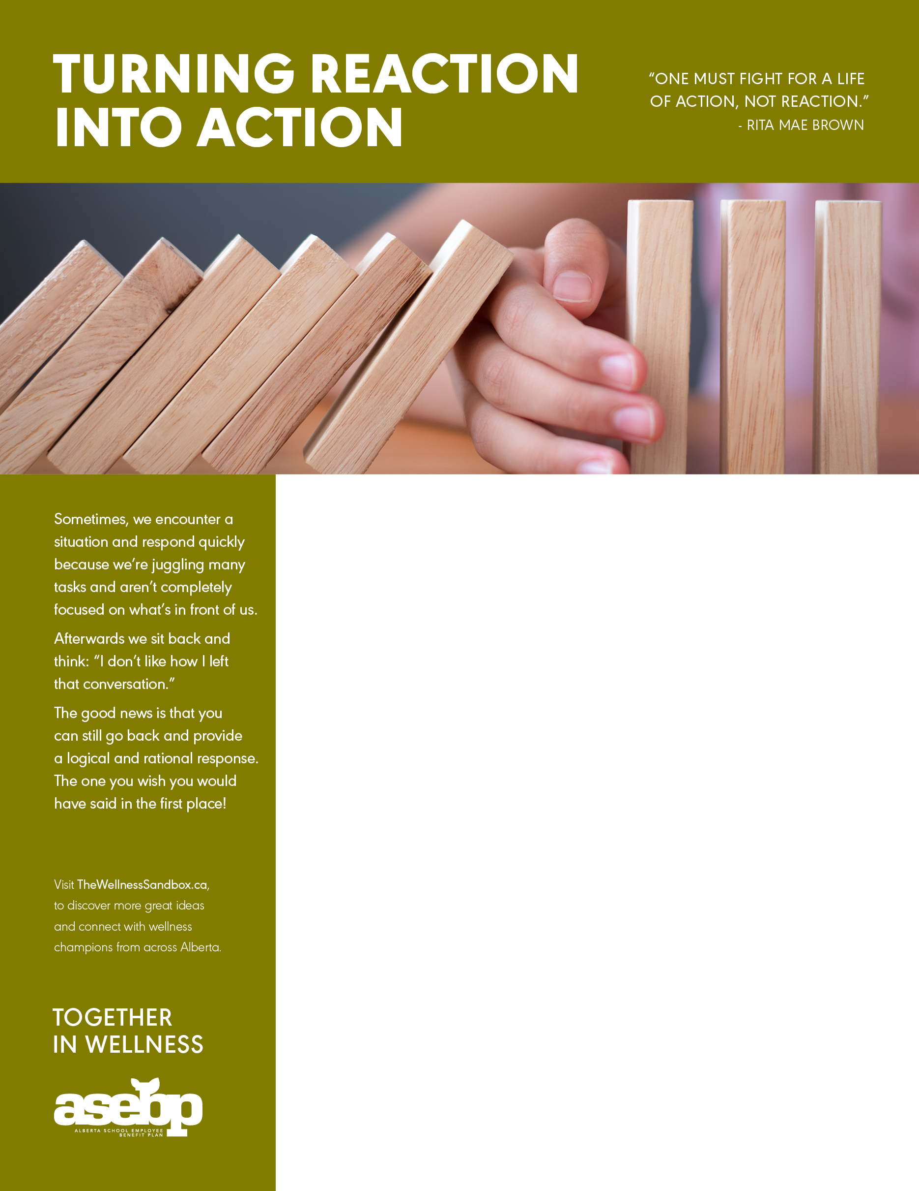

**ADD YOUR WORKPLACE WELLNESS TITLE HERE**

Add your workplace wellness information here! Here are a few ideas that you might include:

* Information about upcoming wellness initiatives or challenges in your workplace;
* Highlight services related to the theme, like your EFAP or ASEBP benefits;
* Share inspirational wellness quotes;
* Feature dates for wellness events happening in your community; or
* Browse through [The Wellness Sandbox](https://www.thewellnesssandbox.ca/) for even more ideas!

RELATED RESOURCES:

Blog: For a quick overview of the focused conversation check out Jack Calabrese’s [Facilitating with The Focused Conversation](https://helpingimprove.com/facilitating-with-the-focused-conversation/).

Course: Looking to hone your facilitation skills? Check out what the Government of Alberta’s [Community Development Unit](https://www.alberta.ca/community-development-unit.aspx#facilitation-training-workshops) has to offer.

Info Graphic: This [Info Graphic](https://martingilbraith.com/wp-content/uploads/2016/11/fc-overview.pdf) takes you through the four steps of Focused Conversation.

Website: The Crisis Prevention Institute’s article [Debriefing Techniques: How to Use Them for Prevention](https://www.crisisprevention.com/en-CA/Blog/debriefing-techniques) will help you dig a little deeper into the debriefing process.